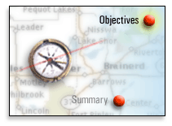
Objectives

Purpose
This module focuses on the basic user tasks for Calendar. After completing this module, you should be able to:
Log in to Calendar
Manage your personal time by using Calendar
Collaborate with other users in Calendar

Log In to Calendar

Access Calendar via the Web Browser
The Oracle Calendar can be accessed through a standard Web browser by going to the Oracle Collaboration Suite URL assigned by your administrator. There are two ways to access Calendar from the Oracle Collaboration Suite home window:
Click Calendar in the Calendar region, or
Click the Calendar option in the Quicklinks region:
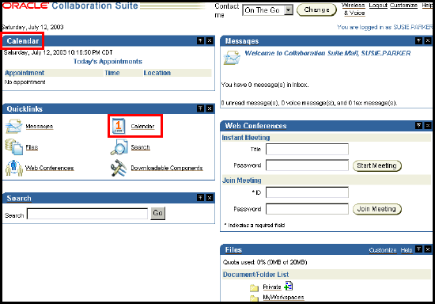

Manage Your Personal Time

Calendar Components
When you open Calendar, the default view is the Daily Planner, which displays one day's worth of entries in a graphical format. From this window, you can see the following components:
Calendar toolbar
Your daily schedule
Daily Notes & Day Events region
Tasks region
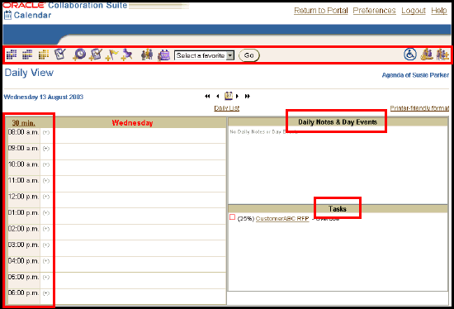

Search Through Calendar Events
Calendar offers different views to help you view and manage information in your agenda.
The Day View and Weekly View have two different modes:
The List, which displays information in a list format:
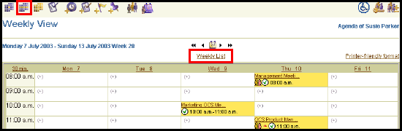
Or, the Planner, which offers a graphical representation of your calendar data:
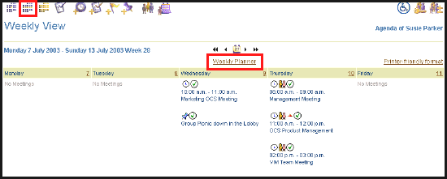

The Monthly View allows you to view and edit time-based content in a list format:
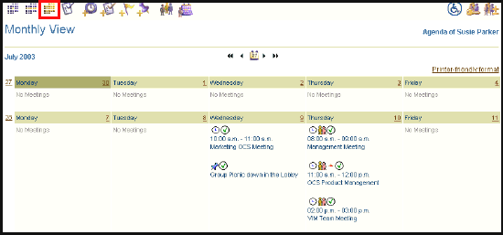

Date Control Bar
The Date Control Bar can be used in the Day View, Weekly View, and Monthly View, which you can use to find a particular date quickly and conveniently. It appears between the date and your username:

Use the In-Tray
From the Daily List or Weekly List, you can view entries in your agenda including meetings, Daily Notes & Day Events, and Tasks:
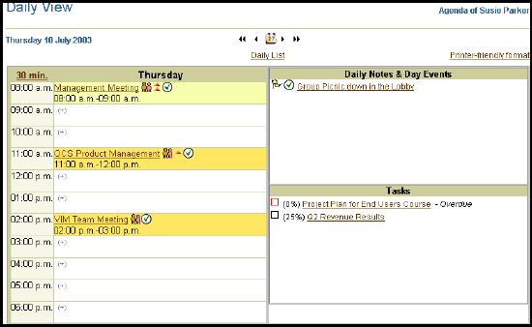

Color Codes
Note how some of the meetings are displayed in different colors. Calendar color-codes your meetings by importance level, attendance status, or ownership, depending on what you select in the Colors region of the Edit Preferences window. Refer to the OCS Users Guide for a complete list of importance level, attendance status, and ownership of each color.
For the above example, light yellow describes a tentative meeting that you own, and yellow describes a meeting that you own.

Entry Symbols
In any Agenda view, a symbol accompanies each entry, representing the entry type:
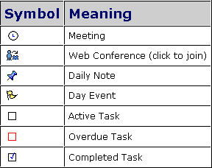
A number of other symbols may also appear next to an entry:
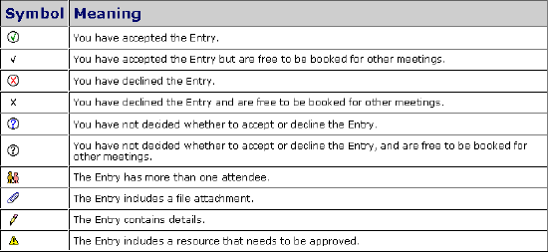
The following table lists the various importance levels of a meeting and their accompanying symbols:
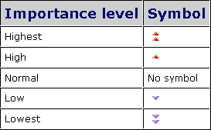

Create or Edit a Task
A Task represents a project or work item that is either ongoing or that must be completed in a given time frame. You cannot send tasks to other users, although you can give other users viewing rights for the tasks that you create.
Create or Edit a Task Through the Task View
Create or Edit a Task Through the Create Task Icon

Create or Edit a Task Through the Task View
The Task View allows you to view, edit, and create Tasks in one window:
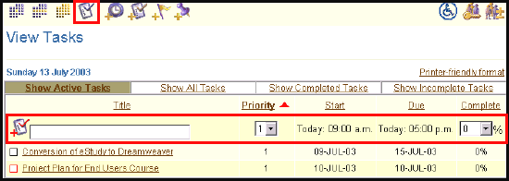
1. | To create a new task, enter the task name and click the Create Task icon:
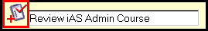
The name of task appears in the task list:
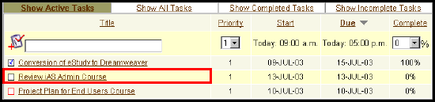
2. | To edit any of the details of the task, click the task name to invoke the Edit Task window. For this example, the date has been changed. To confirm the change, click the Update button:
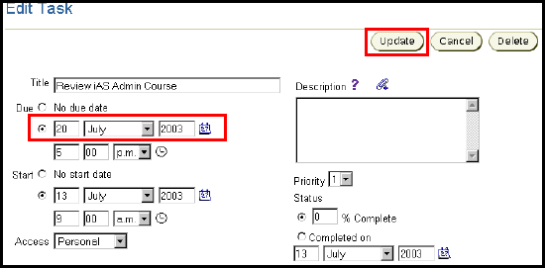
The Task appears in the task view with the new date:
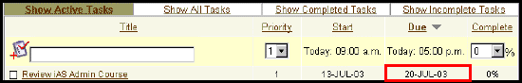
Back to top

Create or Edit a Task Through the Create Task Icon
1. | Begin by clicking the Create Task icon in the Calendar toolbar:
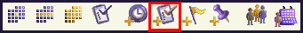

The New Task window appears:
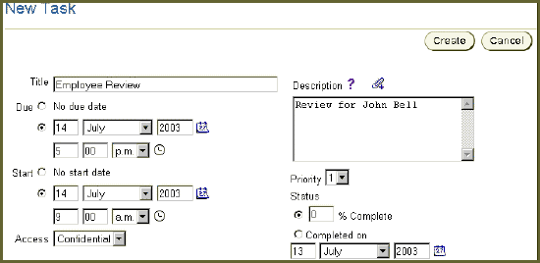
Besides the standard information that you would include with a task (date, start and due time, and start and due date), you can also:
Add up to 32 K of plain text in the Description region
Include hypertext links in the Description region by clicking the icon
Assign an Access level to the entry. Depending on the Access level that you set, different users may or may not be able to view information about the entry.
Indicate that part of your task has been completed by selecting the % Complete option and entering a value in the edit box
Select the "Completed on" option and enter the date on which you completed the task
Choose a date or due date from the Date Picker
Choose a start or due time from the Time Picker
Click the 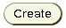to create the task.
All the tasks can be viewed in the Tasks region in the Calendar home window:
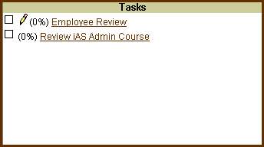

Create or Edit a Task
A Task represents a project or work item that is either ongoing or that must be completed in a given time frame. You cannot send tasks to other users, although you can give other users viewing rights for the tasks that you create.
Create or Edit a Task Through the Task View
Create or Edit a Task Through the Create Task Icon

Create or Edit a Task Through the Task View
The Task View allows you to view, edit, and create Tasks in one window:
1. | To create a new task, enter the task name and click the Create Task icon:
The name of task appears in the task list:

2. | To edit any of the details of the task, click the task name to invoke the Edit Task window. For this example, the date has been changed. To confirm the change, click the Update button:
The Task appears in the task view with the new date:
Back to top

Create or Edit a Task Through the Create Task Icon
1. | Begin by clicking the Create Task icon in the Calendar toolbar:

The New Task window appears:
Besides the standard information that you would include with a task (date, start and due time, and start and due date), you can also:
Add up to 32 K of plain text in the Description region
Include hypertext links in the Description region by clicking the icon
Assign an Access level to the entry. Depending on the Access level that you set, different users may or may not be able to view information about the entry.
Indicate that part of your task has been completed by selecting the % Complete option and entering a value in the edit box
Select the "Completed on" option and enter the date on which you completed the task
Choose a date or due date from the Date Picker
Choose a start or due time from the Time Picker
Click the to create the task.
All the tasks can be viewed in the Tasks region in the Calendar home window:

Create or Edit a Daily Event/Note
A Day Event lasts for an entire day but does not block time in your agenda.
A Daily Note reminds you about things that you need to do in a day.
To create either a Day Event or a Daily Note, click the appropriate icon in the Calendar toolbar:
The subsequent windows in the example are the same for both options:
General Options
Details
Notification
People & Resources
Repeating

General Options
The New Day Event window appears:
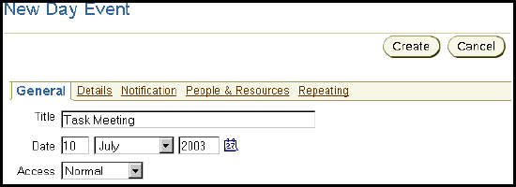
Set the Title of the entry.
Choose a Date from the Date Picker. .
Assign an Access level to the entry. Depending on the Access level that you set, different users may or may not be able to view information about the entry.

Details

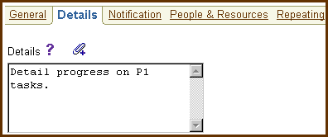
Add up to 32 K of plain text in the Details region.
Include hypertext links in the Details region by clicking the icon.
Attach a file to Daily Note or Day Event by clicking the icon above the Details region.
Back to top

Notification
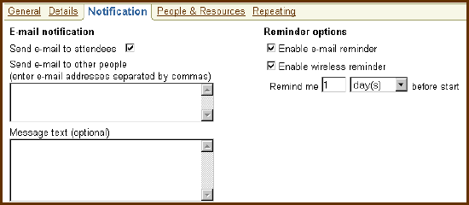
Send E-mail notifications for the attendees or non-attendees.
Add up to 32 K of plain text in the Message text region.
Enable Reminder notifications through e-mail or your wireless device.

People & Resources
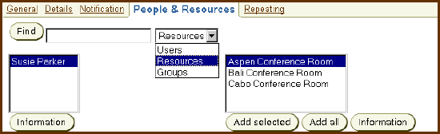
Enter and select information about the appropriate person, resource, or group, by using the fields provided. If you are not sure of the name, you can use partial entries; for example, enter "s" to see a list of names beginning with the letter "s."
Click Find to add the name that you entered. If there are multiple matches, they will be listed in a box from which you can select the name that you want.
Back to top

Repeating
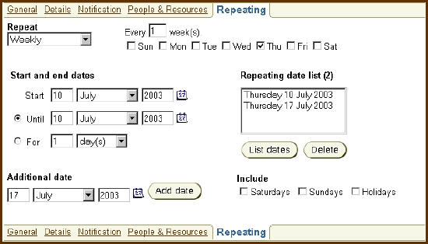
Determine the frequency of a Day Event by clicking the pull-down menu under Repeat. Note: You can only make an entry a Repeating Entry when you create it. You cannot add recurrences to existing entries.

Collaborate with Others Through Calendar

Schedule a Meeting
Meetings are the building blocks of your agenda. You can use them to reserve time in your schedule for any type of activity with a start and end time.
1. | To create a meeting, click the New Meeting icon on the toolbar:
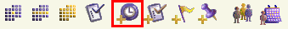
2. | The New Meeting window appears:
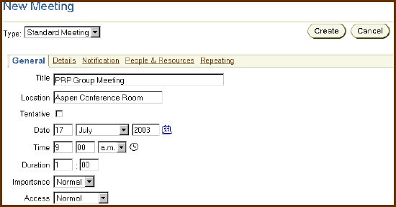
Besides the standard information that you would include with a meeting (title, location, date, time, and duration), you can also:
Mark the meeting as Tentative if you think you might need to change the time or date later
Choose a Date from the Date Picker
Choose a start Time from the Time Picker
Specify the time Duration for the meeting
Assign an Importance level to the meeting. An icon representing the Importance level will appear in the Day View, Weekly View, and Monthly View.
Assign an Access level to the meeting. Depending on the Access level that you set, different users may or may not be able to view information about the entry.

Information under the Details, Notification, People & Resources, and Repeating subtabs are the same as creating a Day Event and/or Daily Note.
3. | Click the Create button to confirm the creation of the meeting. The meeting appears in the daily list:
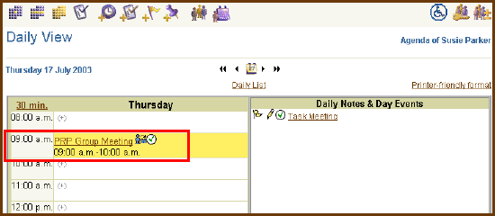
4. | To edit an existing meeting, click the Meeting title from the Daily Planner or the Meeting icon from the Daily List to invoke the Edit Meeting window.

Confirm Resources
From the People & Resources window, you can use the options on this window to invite users, resources or groups to Meetings and check to see if anyone has scheduling conflicts.
1. | Click the link in the New or Edit Meeting window:
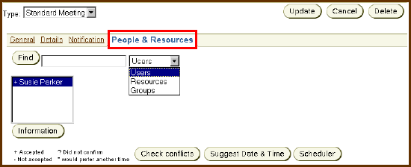

2. | To add a user, resource, or group to the list of attendees, enter the name in the edit box, click the Find button and select the appropriate option:
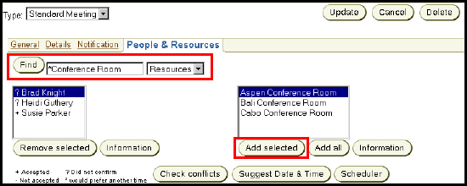.
In the above example, the results return all conference rooms whose names end with "Conference Room." If the system finds an exact match, the room will appear in the list box on the left. If the system finds more than one match for the name, another list box will appear on the right (as shown in the example). Choose the conference room that you want and click Add selected or Add all:
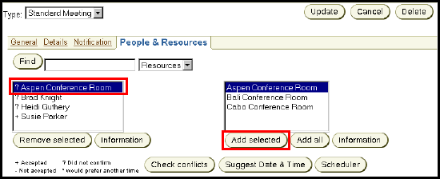
Note: If you searched for Groups, clicking Add selected for a particular group will add all members of that group to the attendee list for the meeting.

Check the Availability of Meeting Resources
1. | Click the link in the New or Edit Meeting window.
2. | The Calendar lists all attendees with a symbol next to each name showing the status:
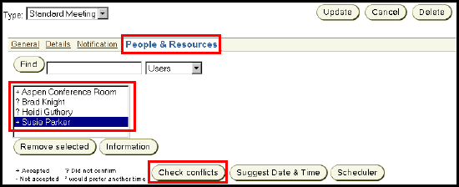
The following symbols have the following meaning:
+ | The user has accepted the meeting.
+* | The user has accepted but would prefer another time.
- | The user has declined the meeting.
-* | The user has declined and would prefer another time.
? | The user has not yet confirmed his or her attendance status.
?* | The user has not yet confirmed his or her attendance status but would prefer another time.

3. | Click the Check Conflicts button to verify the availability of the users, resources, or groups.

Reply to a Meeting
If another user has booked you for a meeting, it will appear in your agenda with a symbol next to the entry title. The symbol and color coding of the meeting indicates your ownership and reply status:


To reply to a meeting:
1. | Click the Meeting icon or title (depending on the view) in your Daily, Weekly, or Monthly view.
2. | Select a reply from the Your Reply drop-down menu.
 | If you want users to be able to book you for other meetings at this time, select Free in the Show time as drop-down menu.
3. | Click Update to accept the change:
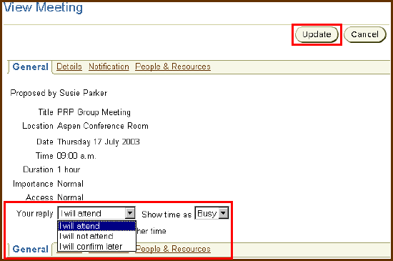
Note that the symbol and the color have changed to confirm your attendance at the meeting:

Change the Display Status of a Daily Note or Day Event
If another user sends you a Daily Note or Day Event, it appears in your agenda with a symbol next to the entry title. The symbol indicates the display status of the entry:
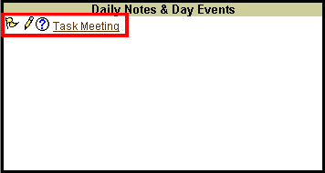
To change the display status of a Daily Note or Day Event:
1. | Click the Entry icon or title (depending on the view) in your Daily, Weekly, or Monthly view.
2. | Select a display option from the Your reply drop-down menu.
3. | Click Update to accept the change:
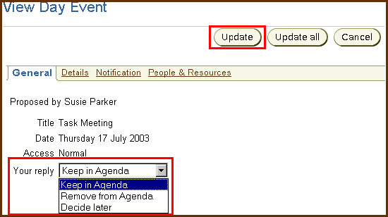

Note that the symbol has changed to keep the Daily Event in your agenda:
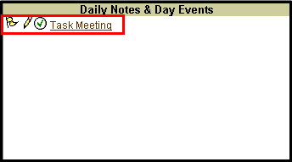


Advanced Topics

Learn More...Become a Power User!
Advanced features of Calendar can be found in Module 10: Additional Collaboration Tasks for Calendar. These topics include:
Manage Your Address Book
Manage Groups
Publish Your Agenda
Modify an Agenda Entry
Set Access Rights
Set Calendar Preferences
Synchronize Your Agenda

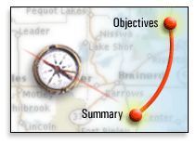
Summary
In this module, you should have learned how to:
Access Calendar by using the Web browser
Search through Calendar events by using the Day view, Weekly view, and Monthly view
Create or edit a task
Create or edit a Daily Note or a Day Event
Schedule a meeting and confirm the people and resources that are associated with that meeting
Check the availability of meeting resources
Reply to events in your calendar (including meetings, daily notes, and day events)
The next module discusses how to create and participate in Web Conferencing.

