Central Texas
U.S. Service Academies
F
oru

U.S. Military
Academy
U.S. Naval
Academy
U.S. Air Force
Academy
U.S. Merchant
Marine Academy
U.S. Coast Guard
Academy

High school students (9th-12th grades) welcome. Parents and educators are encouraged to attend.
Free. No reservations necessary.

Saturday, September 17, 2016
9:00 AM - 12:00 Noon

Texas State University - Round Rock
1555 University Boulevard
Round Rock, Texas 78665-8017

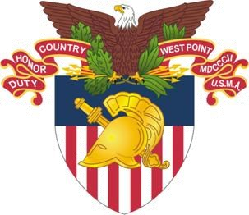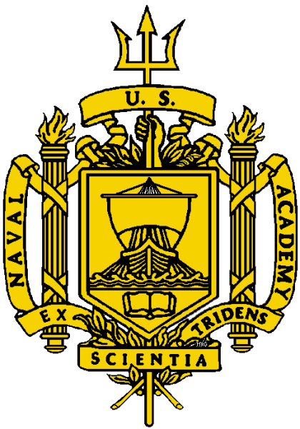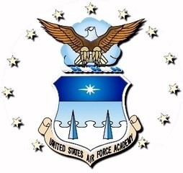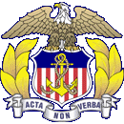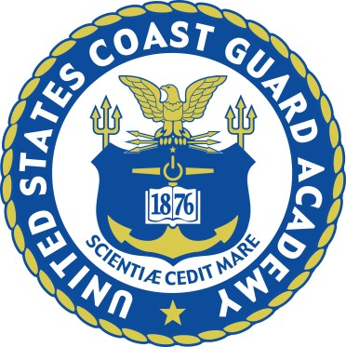Jointly Sponsored by:

• Senator John Cornyn

• Senator Ted Cruz

• Congressman John Carter (TX-31)

• Congressman Bill Flores (TX-17)

• Congressman Michael McCaul (TX-10)

• Congressman Roger Williams (TX-25)

For More Information contact:

Cheryl Hassmann
Office of Congressman John Carter
254-933-1392 cheryl.hassmann@mail.house.gov

